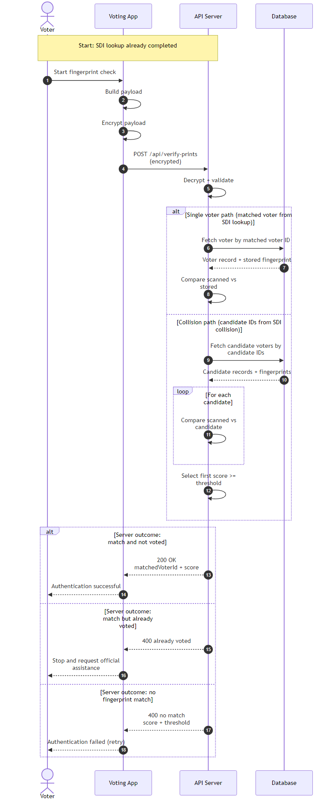
Figure 1 – Sequence Diagram of Authentication Flow as a Voter.

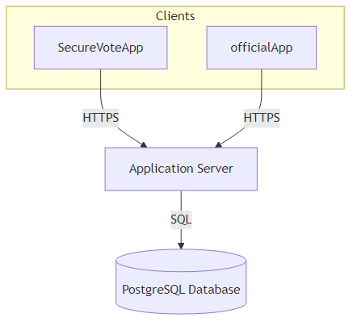
Figure 2 - System Architecture Diagram

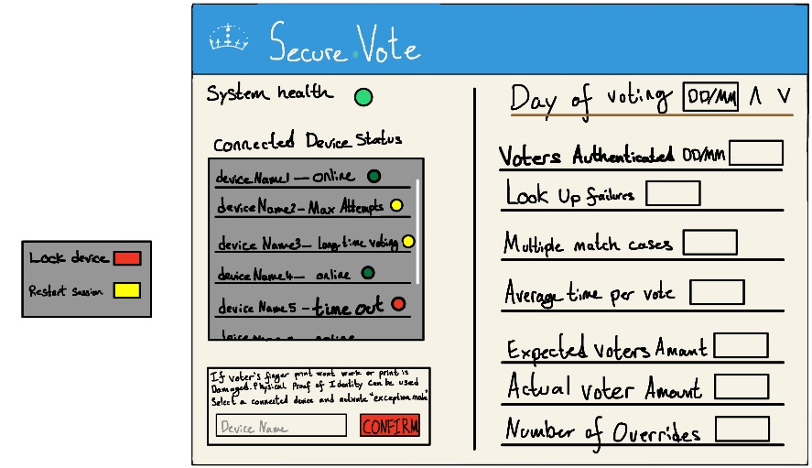
Figure 3 Official Polling Station Management Screen

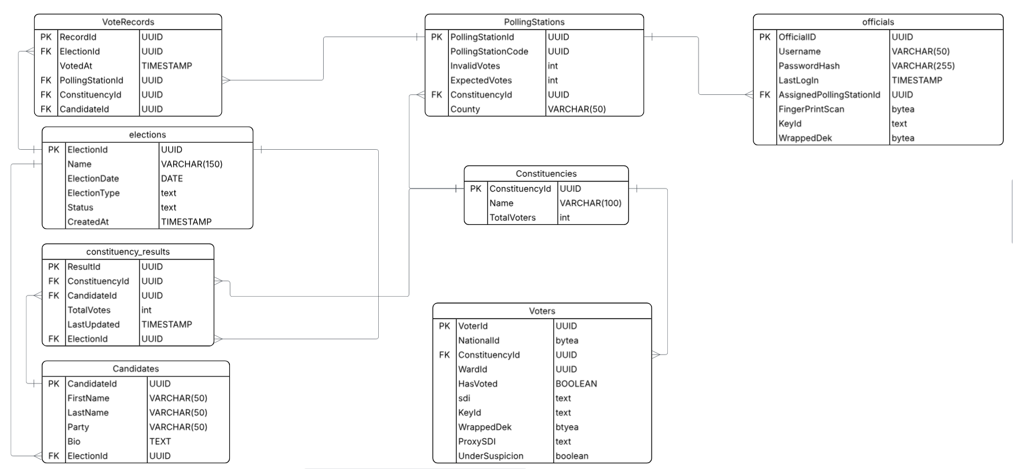
Figure 4 Entity Relationship Diagram showing structure and connections of tables in the systems database

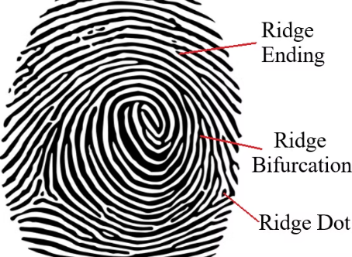
Figure 5. Diagram illustrating features of fingerprints [55].

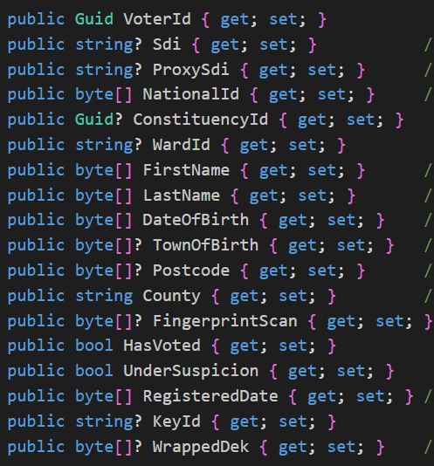
Figure 6 Voter Table including Demonstration Data

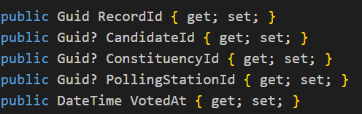
Figure 7 VoteRecord Table

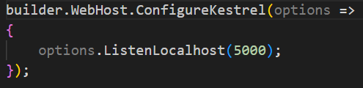
Figure 8 - Kestrel local port binding for Nginx reverse proxy

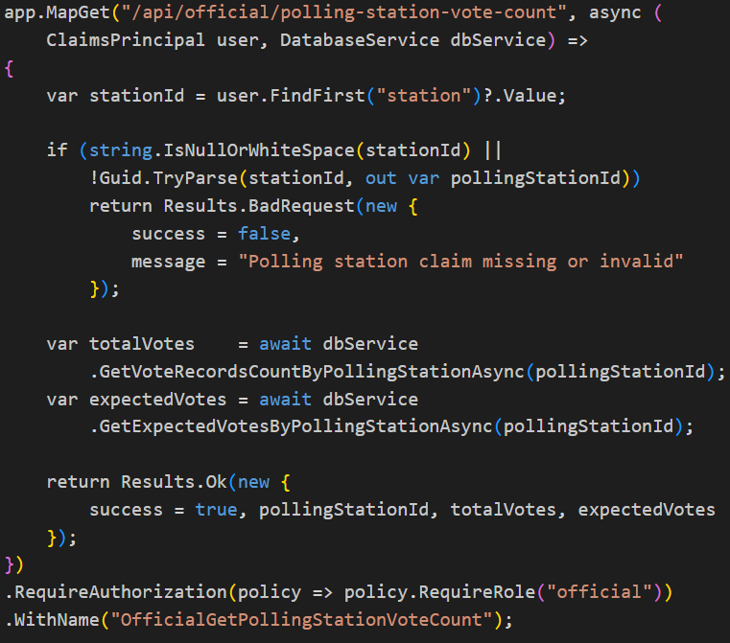
Figure 9 Polling stations vote count API end point

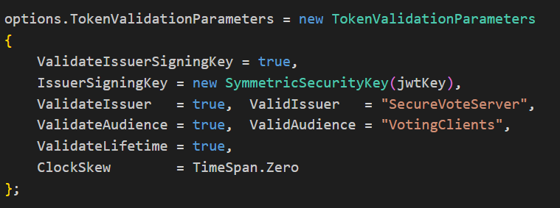
Figure 10 JWT Token Validation Parameters

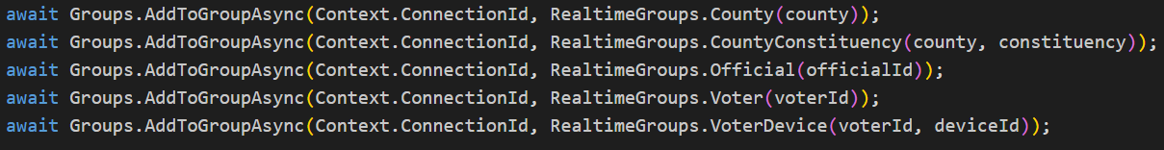

Figure 11 – SignalR group assignments made on client connection to VotingHub

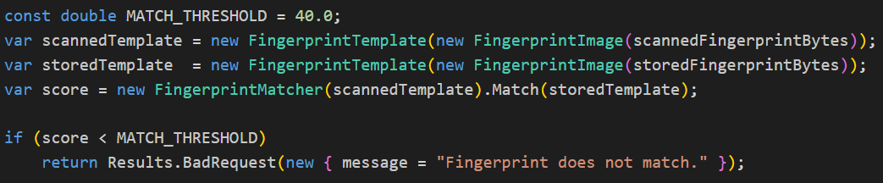Figure 12 – Fingerprint Matching Pipeline from the Server

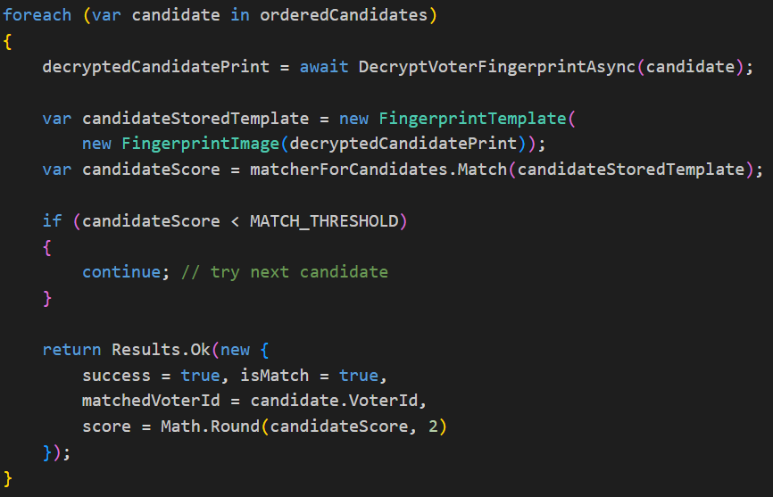
Figure 13 – SDI collision disambiguation loop

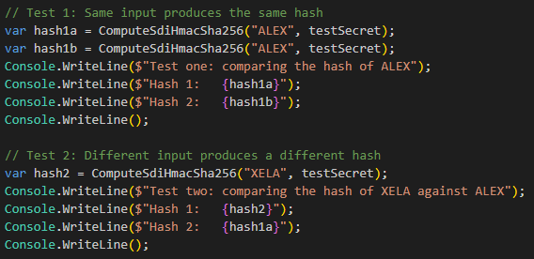
Figure 14 – SDI Hash Determinism Test Code
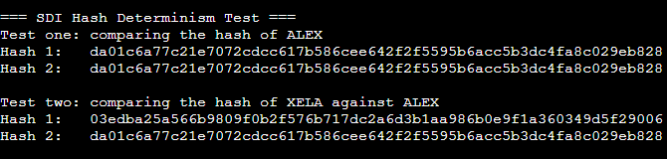
Figure 15 – SDI Hash Determinism Test Output

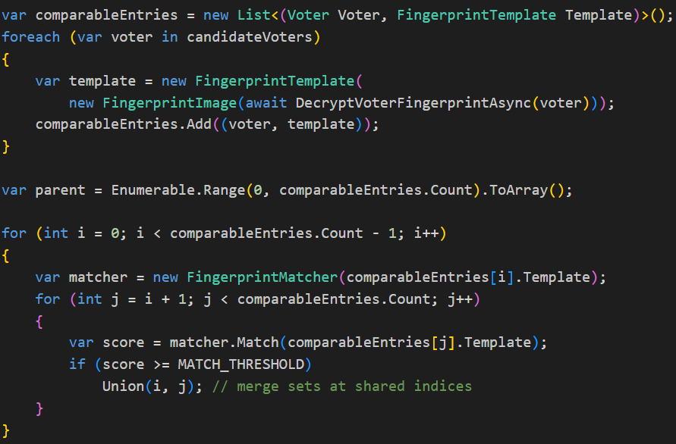
Figure 16 – Duplicate Fingerprint detection Algorithm

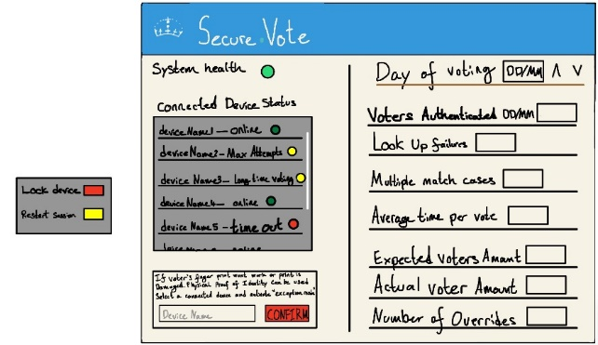
Figure 17- High Fidelity of Poling Station Management screen
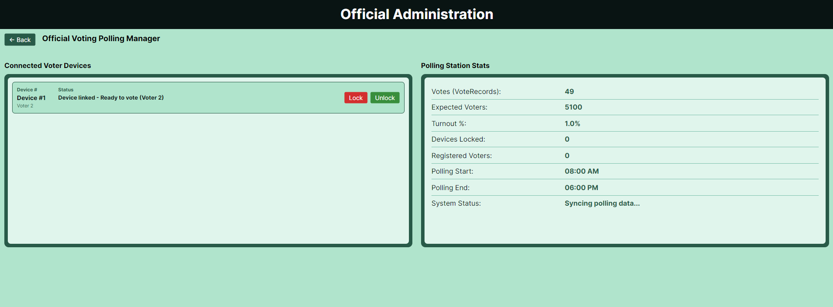
Figure 18 – Finaly Version of Poling Station Management screen

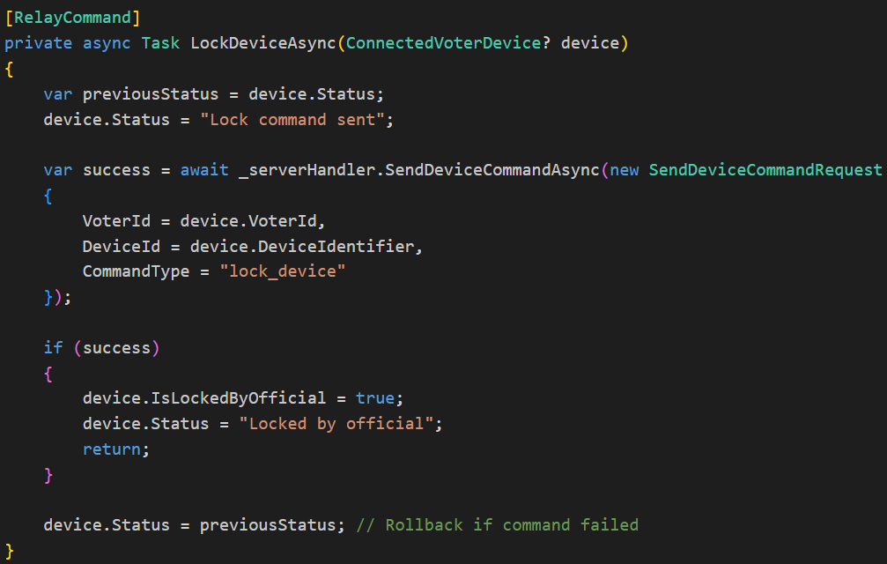
Figure 19 – Device Lock Command Handler

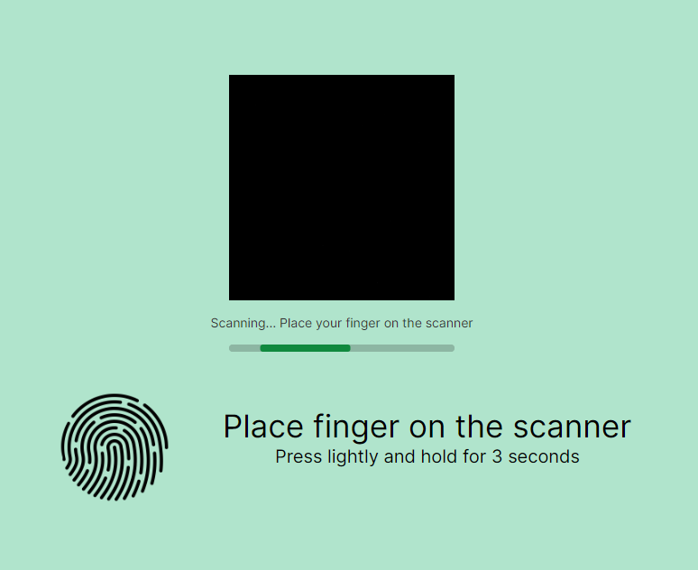
Figure 20 – Fingerprint Scanning View
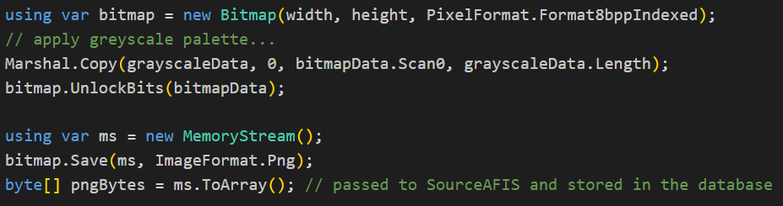
Figure 21 – Fingerprint Image Preprocessing Pipeline

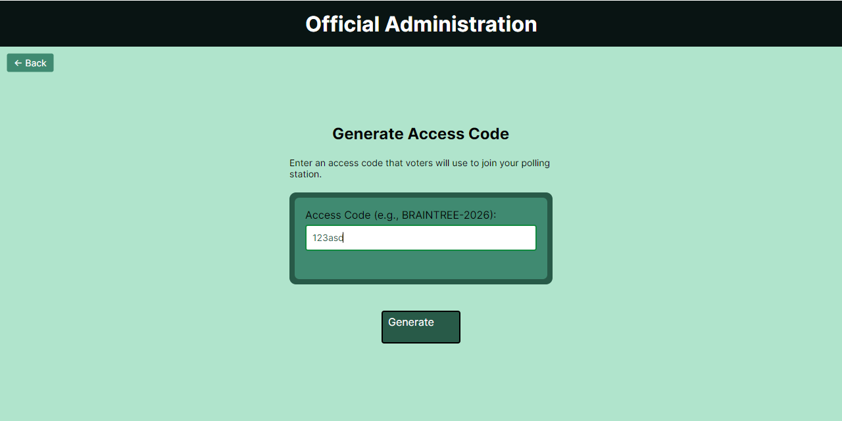
Figure 22 – Generate Access Code View in Official App

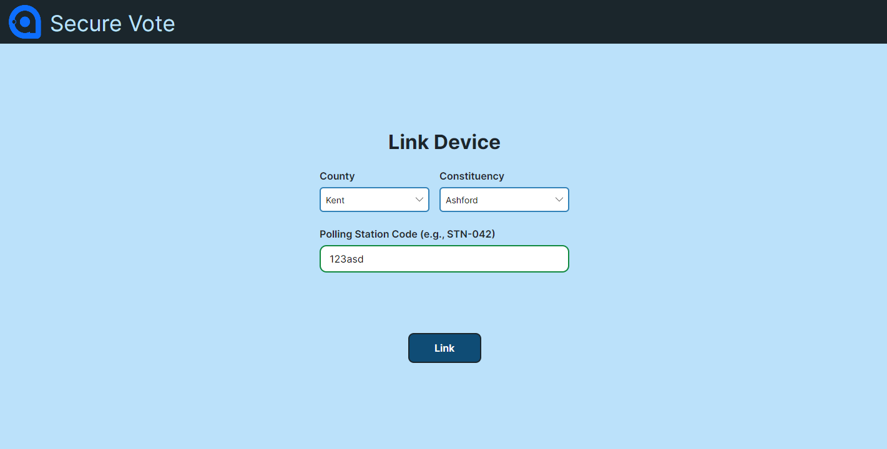
Figure 23 – Voter App Linking Screen

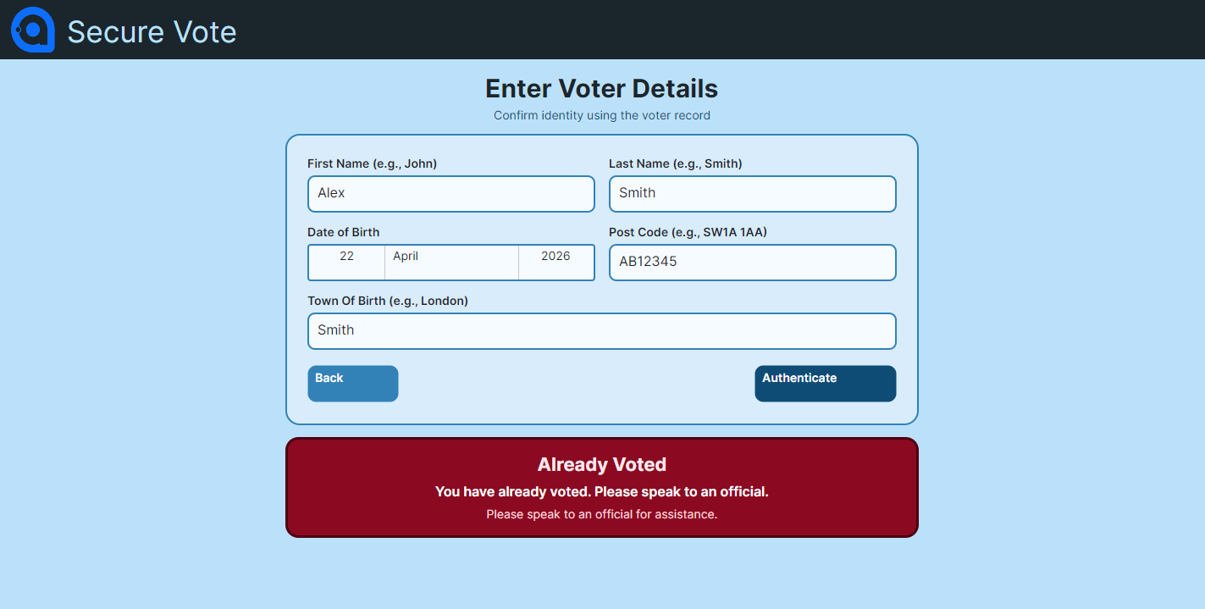
Figure 24 – Enter Voter Information Screen Locked by Second Vote Attempt
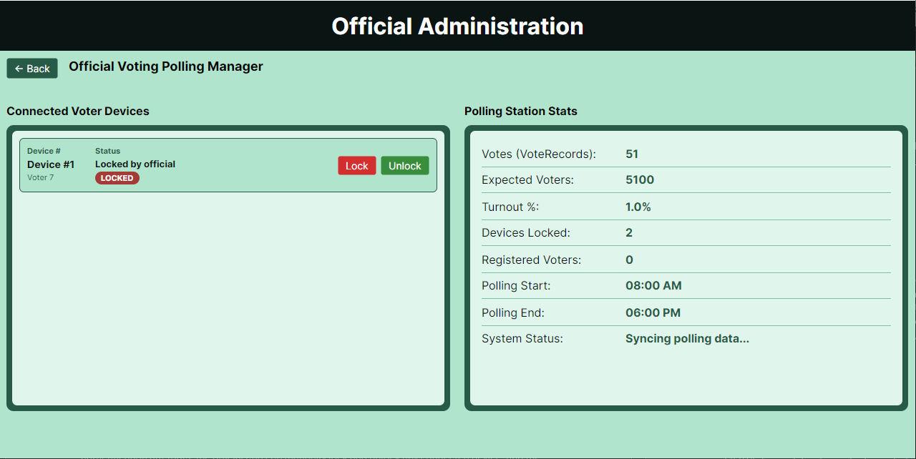
Figure 25 – Official Polling Manager Screen Having Locked a Voting Device

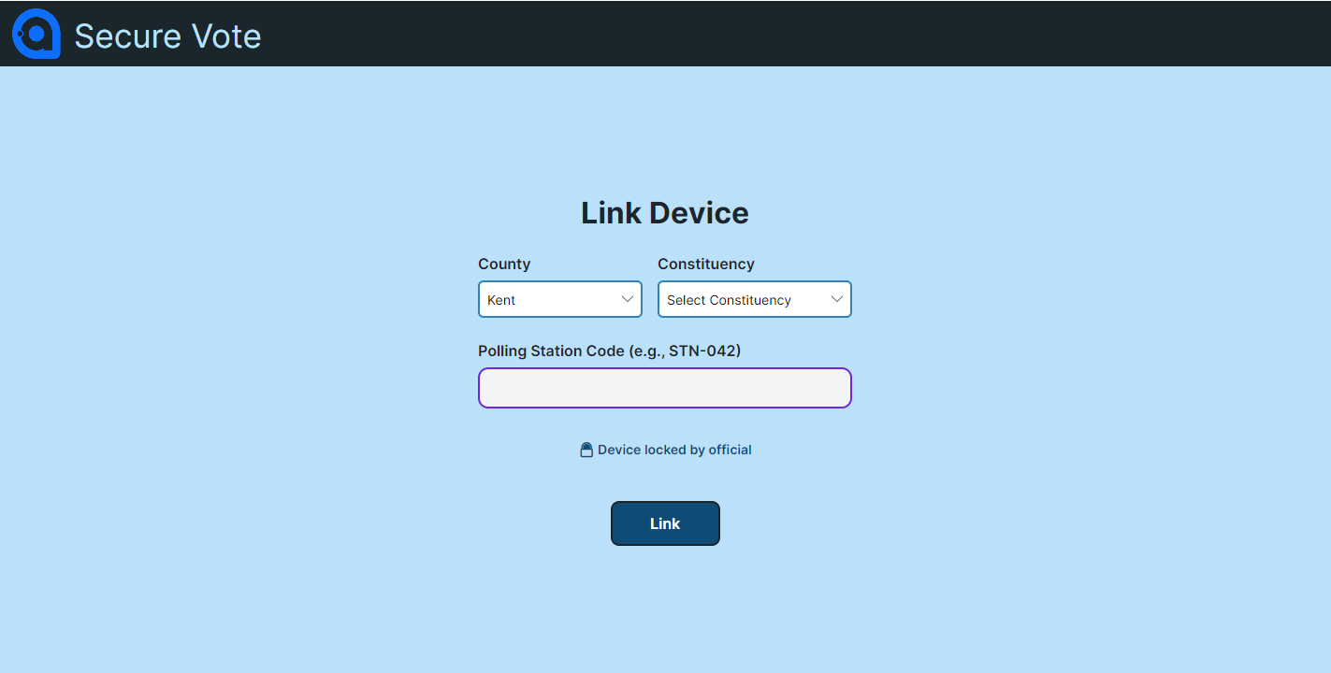
Figure 26 –Voter Device Screen Locked by Official

